# Software Architecture Document

|  |  |  |
| --- | --- | --- |
| Date | Author | Description |
| 2020/09/13 | 曹雪娇 | System design |
| 2020/09/13 | 朱晨 | Introduction |

目录

Software Architecture Document 1

1. Introduction 1

1.1 Purpose 1

1.2 Intended audience 2

1.3 How to use the document 2

2. System design 2

2.1 Functional Requirements 2

2.2 Overall diagram 3

2.3 Modules 3

2.4 Context 4

# Introduction

## Purpose

This document aims to find the best solution for the development of book recommendation system. The analyst should further design the software structure for the best solution, conduct the necessary database design, determine the test requirements and develop the test plan.

The overall design can stand on the global level, spend less cost, analyze and compare a variety of possible system implementation schemes and software structures from a more abstract level, select the best scheme and the most reasonable software structure, so as to develop a higher quality software system with lower cost.

This document is an important reference for the development of book recommendation system.

## 1.2 Intended audience

1.2.1. Book recommendation system developers: Database developers and coders

1.2.2. Book recommendation system tester

## 1.3 How to use the document

This document introduces the data flow diagram, module partition and context of book recommendation system in system design. The SD method is used in the data flow diagram.

# System design

## 2.1 Functional Requirements

2.1.1 Login

Log in to the system according to the user id provided by the user

2.1.2 Register

user submit to get, add user in database, and return user ID

2.1.3 Comment

users search the book name or book ID to comment

2.1.4 Recommend

the system returns the recommended books

## 2.2 Overall diagram

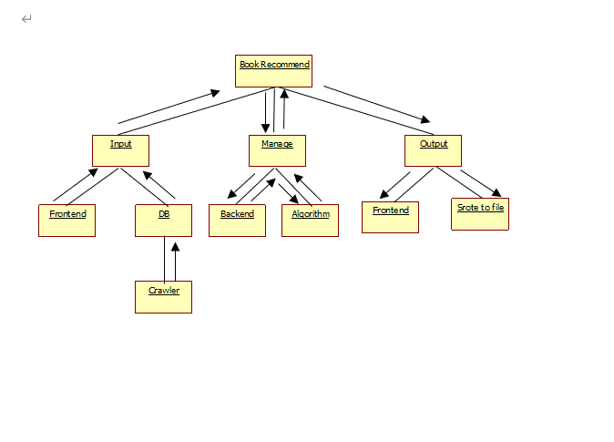

## 2.3 Modules

The system is divided into five modules. Specific descriptions will be showed in Detailed Design document.

|  |  |  |
| --- | --- | --- |
| Name | Brief Description | Developers |
| Frontend | This module is responsible for the building website and the interaction with users, which receives information from users and then show them results from backend. | Feng Haotian, Cao Xuejiao, Zhu Chen |
| Backend | This module receives requests from Frontend and deals with them with the help of Algorithm module. | Feng Haotian, Cao Xuejiao, Zhu Chen |
| Algorithm | Algorithm is responsible for training module and then providing users with book recommendations, which is the key part of system. | Wang Lihao |
| Database | Database stored three sheets, uinfo, bookinfo and bookrating. It provides searching function for Backend. | Feng Haotian |
| Crawler | This module is responsible for collecting data set for system. It craws date from BookCrossing website, clean the date and store them into database. | Li Fengpeng |

## 2.4 Context

We develop our system in Win10 environment, using python, javascript programming languages.

The database uses MySQL 8.0.

The final product runs on different browsers like Google Chrome, IE, firefox and so on.